**Including css in template**

1. Cretate css folder under static folder
2. Create .css file

**css1.css**

div {

        width: 300px;

        height: 200px;

        background: #eee8aa;

    }

    h1{

        color:blue

    }

1. Including css file inside template

Open template (test.html)

{% load static %}

<html>

<head>

    <link rel="stylesheet" href="{% static '/css/css1.css'%}"/>

</head>

<body>

<div>

<h1> This loading Images </h1>

</div>

<img src="{% static '/images/django.png' %}"/>

</body>

</html>

**Including java script inside template**

1. Create a js folder inside static folder
2. Create a java script file js1.js

function dispaly()

{

    window.alert("This is JavaScript function ")

}

1. Include this java script file inside template

{% load static %}

<html>

<head>

    <script src="{% static '/js/js1.js' %}"></script>

    <link rel="stylesheet" href="{% static '/css/css1.css'%}"/>

</head>

<body>

<div>

<h1> This loading Images </h1>

</div>

<img src="{% static '/images/django.png' %}"/>

<form>

    <input type="button" value="ok" onclick="display()">

</form>

</body>

</html>

**Sending request to view**

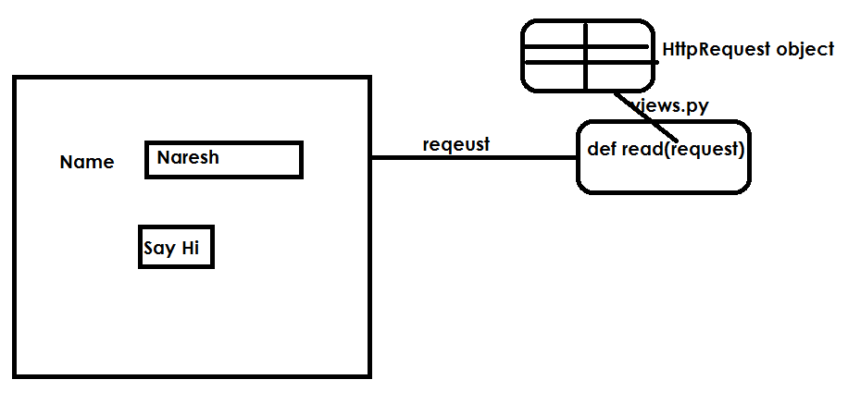

Request is an input given by client to view

Whenever client send request, server create HttpRequest object by storing request information. This HttpRequest object is send to view as an argument. HttpRequest represent request information as dictionary.

1. Create project

django-admin startproject requestproject

1. Create application within project

python manage.py startapp app1

1. Views.py

from django.shortcuts import render

from  django.http import HttpResponse

# Create your views here.

def view1(request):

    msg="<h1>This is view1</h1>"

    return HttpResponse(msg)

def view2(request):

    msg="<h1>This is view2 </h1>"

    return HttpResponse(msg)

def home(request):

    h=render(request,"index.html")

    return h

1. Urls.py

from django.contrib import admin

from django.urls import path

from app1 import views

urlpatterns = [

    path('admin/', admin.site.urls),

    path('v1/',views.view1),

    path('v2/',views.view2),

    path('home/',views.home),

]

1. Settings.py

INSTALLED_APPS = [

    'django.contrib.admin',

    'django.contrib.auth',

    'django.contrib.contenttypes',

    'django.contrib.sessions',

    'django.contrib.messages',

    'django.contrib.staticfiles',

    'app1'

]

TEMPLATES_DIR=os.path.join(BASE_DIR,"templates")

TEMPLATES = [

    {

        'BACKEND': 'django.template.backends.django.DjangoTemplates',

        'DIRS': [TEMPLATES_DIR],

1. Create templates folder inside project folder
2. Inside templates folders create index.html

<html>

    <body>

    <h1>

    <a href="/v1">View1</a><br>

    <a href="/v2">View2</a><br>

    </h1>

    </body>

</html>



1. create project

django-admin startproject requestproject1

1. create application within project

python manage.py startapp app1

1. create templates folder within project
2. inside templates folder create home.html

<html>

<body>

<form action="/v1">

   Name <input type="text" name="t1"><br>

   <input type="submit" value="say hi">

</form>

</body>

</html>

1. views.py